**VSB ENGINEERING COLLEGE,KARUR-639111**

**IBM NALAYA THIRAN**

**DEVLOP A WEB APP USING NODE RED**

|  |  |
| --- | --- |
| **Team ID** | **PNT2022TMID33557** |
| **Project Name** | **Project – IOT ENABLED SMART FARMING APPLICATION** |

**TEAM LEAD : NAVANEETHAN R**

**TEAM MEMBER 1: NAVEENKUMAR V**

**TEAM MEMBER 2: KAVINKUMAR P**

**TEAM MEMBER 3: PARTHIPAN G**

MENTOR : VALLISUSEELA R

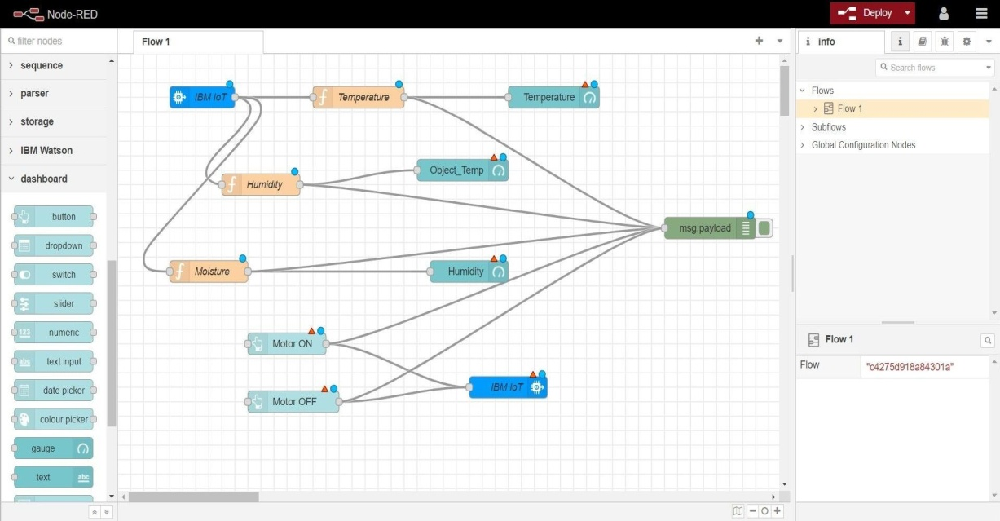STEP 1:-

STEP 2:-

**\*\*\*\*\*\*\*\*\*\*\*\*\*\*\*\*\*\*\*\*\*\*\*\*\*\*\*\*\*\*\*\*\*\*\*\*\*\*\*\*\*\*\*\*\*\*\*\*\*\*\*\*\*\*\*\*\*\*\*\*\*\*\***